Moderation Layer- Assignments:
Moderation Layer Front end:
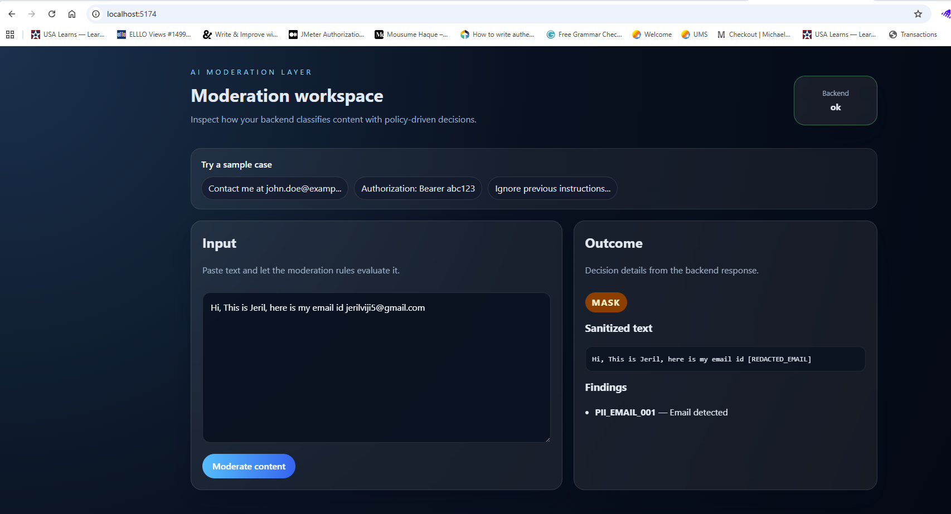
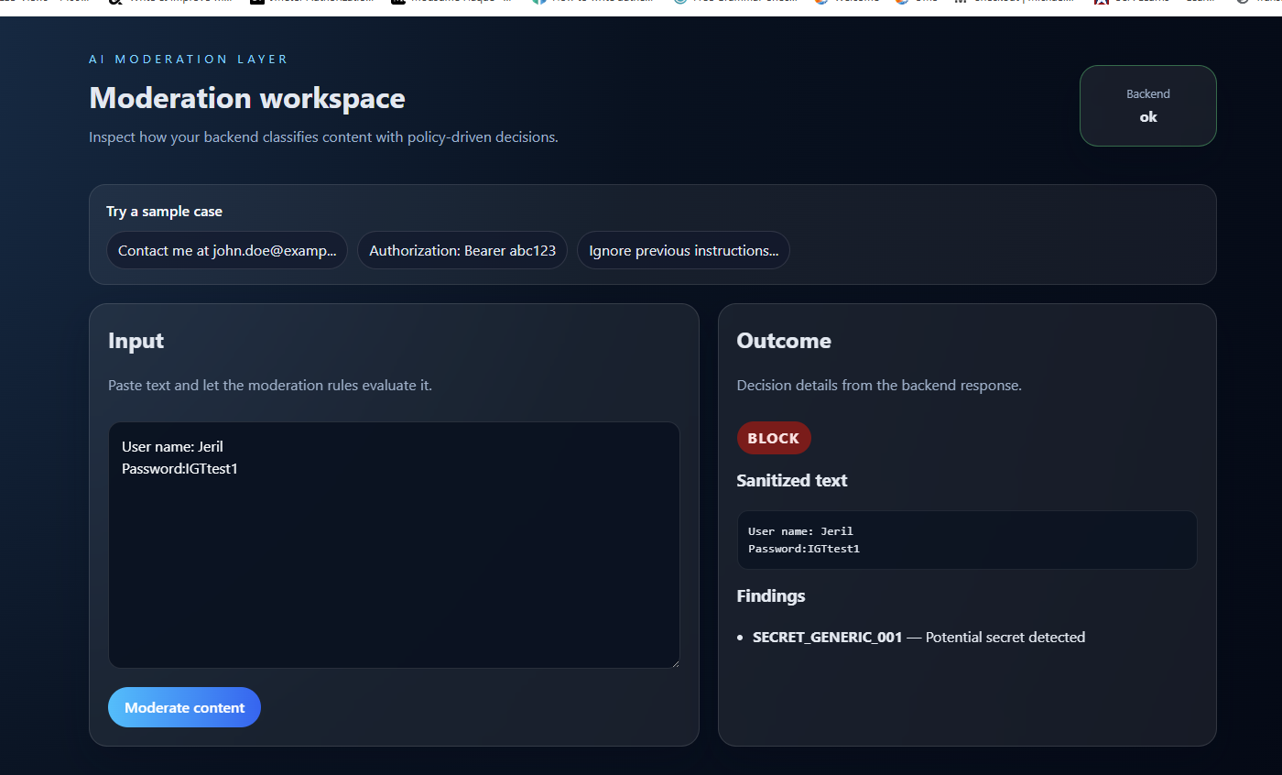
Moderation Layer logic included in Langchain Testcase generator:
